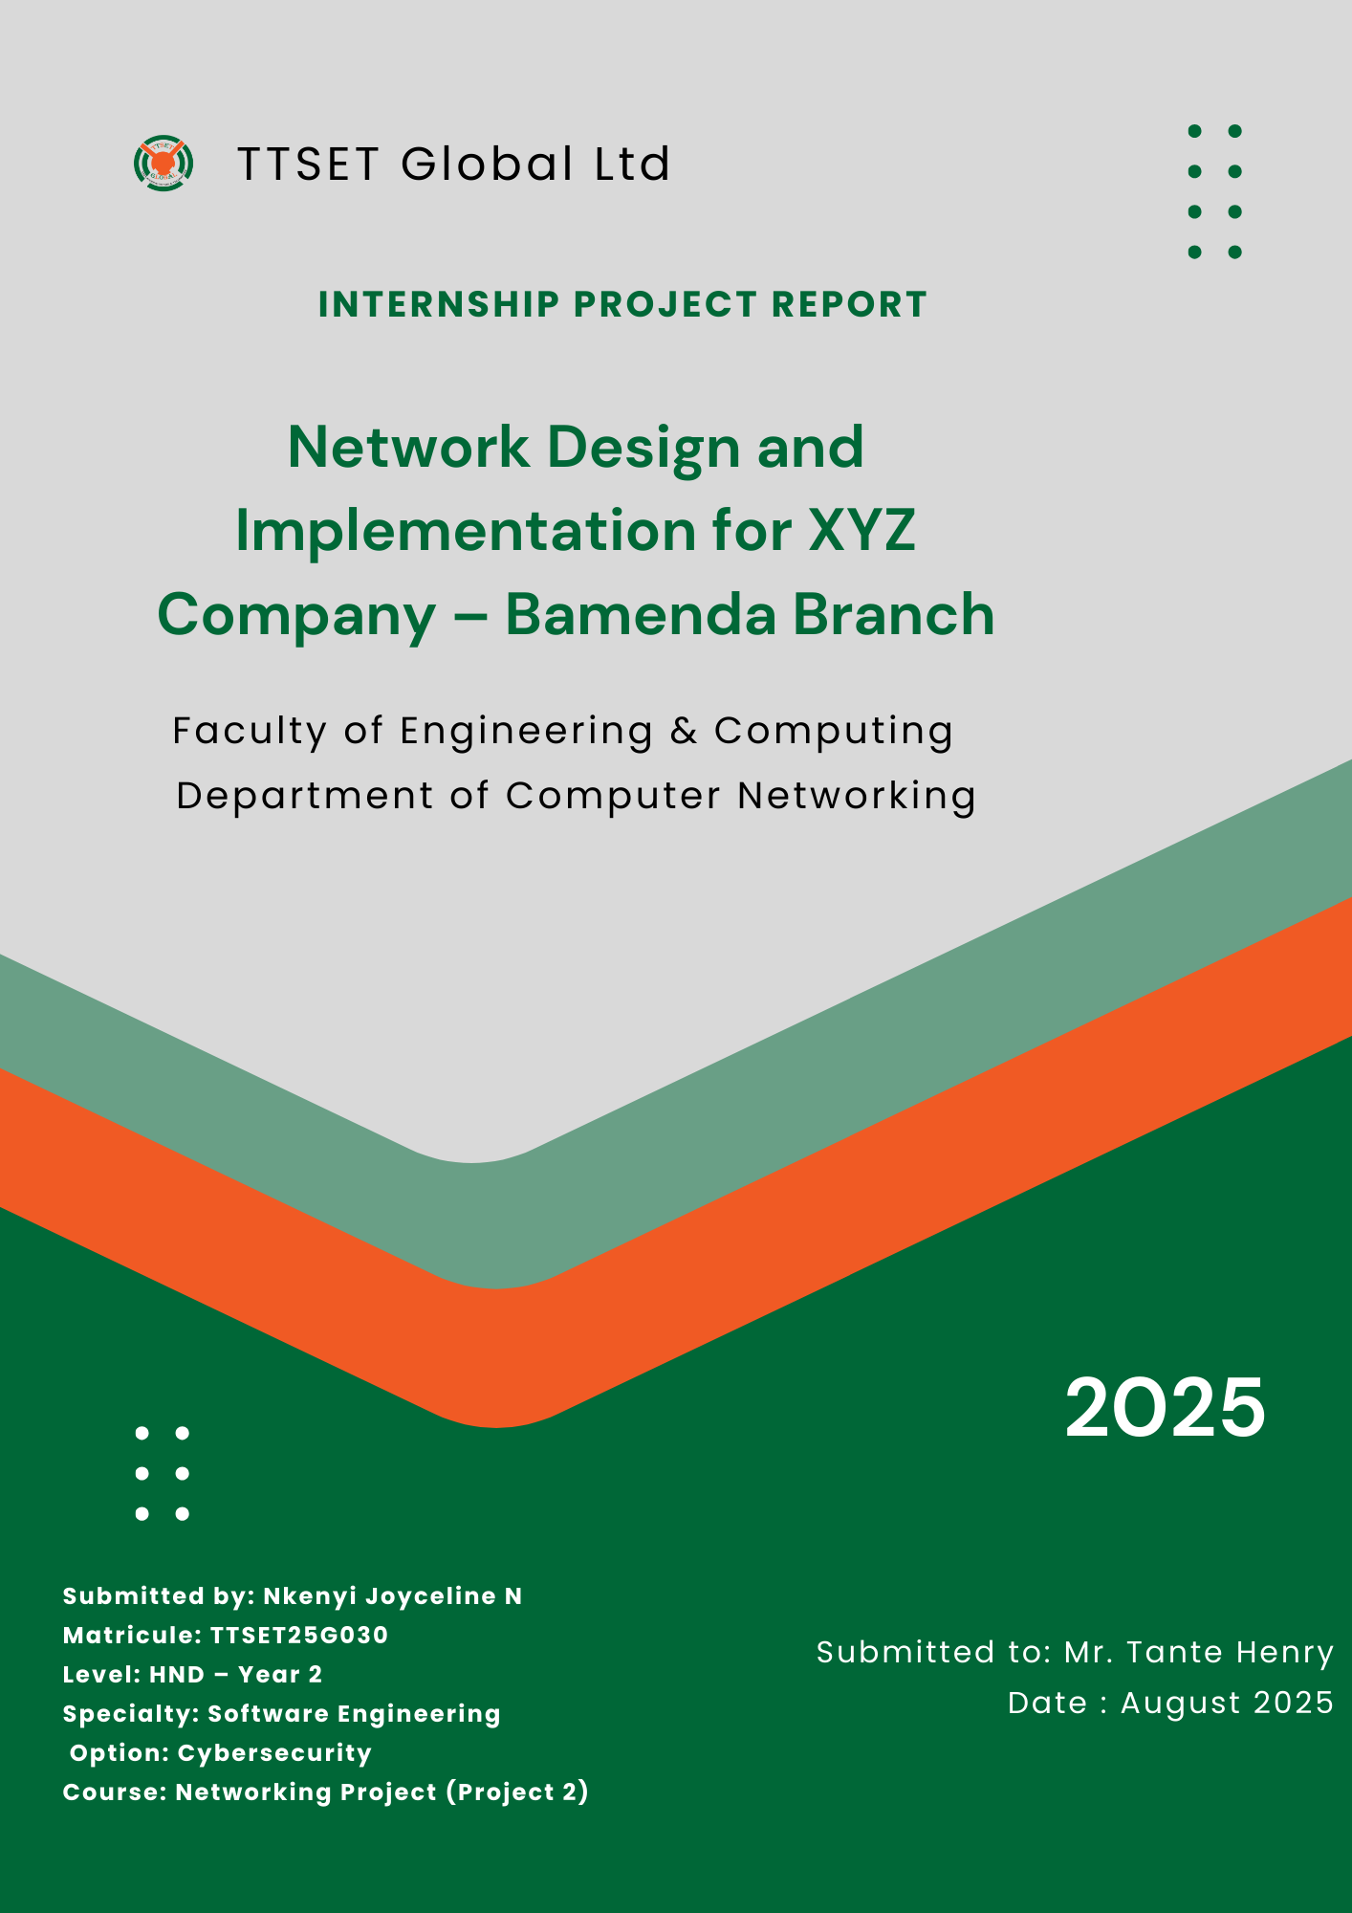

**Title**

Design and Implementation of a Secure, Scalable VLAN-Based Network for XYZ Company – Bamenda Branch

**I.1. Aim**

The aim of this project is to design, configure, and implement a functional network infrastructure for the Bamenda branch of XYZ Company. The network is intended to support separate departments (Admin/IT, Finance/HR, and Customer Service/Reception), ensure secure and scalable communication, and allow automatic IP configuration and wireless access. The network will be isolated from the HQ and utilize VLANs for segmentation, a router for inter-VLAN routing, DHCP services, and wireless access points

ensure efficiency and flexibility.

**I.2. Principle (Process, Software Needed)**

Process Overview:

* Analyzing requirements and departmental structure
* Designing a logical and physical network topology
* Subnetting the base network (192.168.1.0/24) for VLANs
* Configuring a router-on-a-stick (inter-VLAN routing)
* Setting up DHCP on the router

**Implementing VLANs on the switch**

* Configuring access points for wireless connectivity
* Testing and verifying network communication and DHCP distribution

**Software & Tools Used:**

* Cisco Packet Tracer (for network simulation and configuration)
* Basic knowledge of:
  + IP addressing/subnetting
  + VLAN configuration
  + DHCP configuration
  + Inter-VLAN routing
  + Wireless setup

**I.3. Network Diagram**

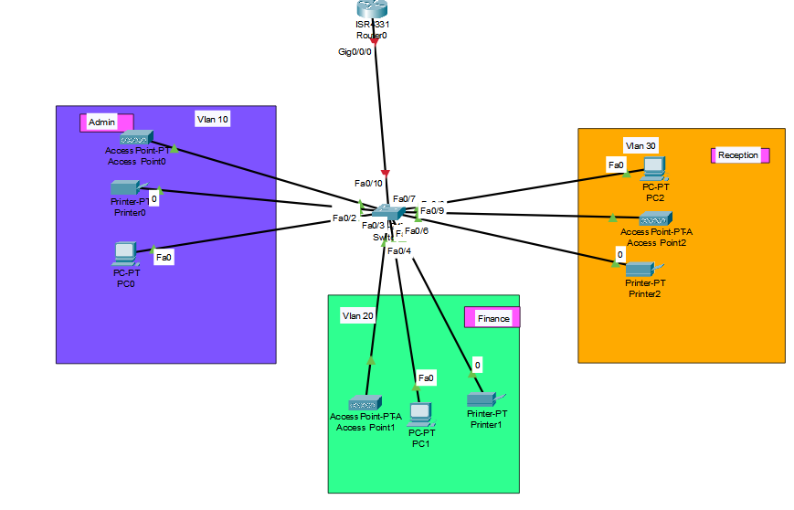

**Before configuration**

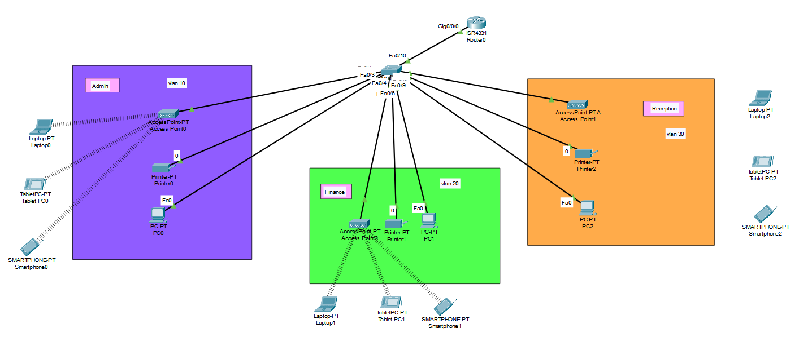

**After Configuration**

**I.4. List of Materials**

* Cisco 2811 Router
* Cisco 2960 Switch
* PCs (per department)
* Wireless Access Points
* Printers
* Ethernet Cables
* Cisco Packet Tracer (software)

**I.5. Network Configuration**

**A) IP Addressing Plan (Subnetting 192.168.1.0/24):**

* VLAN Dept Subnet Gateway
* 10 Admin/IT 192.168.1.0/27 192.168.1.1
* 20 Finance/HR 192.168.1.32/27 192.168.1.33
* 30 CS/Reception 192.168.1.64/27 192.168.1.65

**B) VLAN Configuration on Switch:**

* bash
* vlan 10
* name Admin
* vlan 20
* name Finance
* vlan 30
* name CS
* interface range fa0/1 - 2
* switchport access vlan 10
* switchport mode access
* interface range fa0/3 - 4
* switchport access vlan 20
* switchport mode access
* interface range fa0/5 - 6
* switchport access vlan 30
* switchport mode access
* interface fa0/24
* switchport mode trunk
* C) Router-on-a-Stick Configuration:
* bash
* interface fa0/0.10
* encapsulation dot1Q 10
* ip address 192.168.1.1 255.255.255.224
* interface fa0/0.20
* encapsulation dot1Q 20
* ip address 192.168.1.33 255.255.255.224
* interface fa0/0.30
* encapsulation dot1Q 30
* ip address 192.168.1.65 255.255.255.224
* interface fa0/0
* no shutdown
* D) DHCP Configuration:
* bash
* ip dhcp excluded-address 192.168.1.1 192.168.1.3
* ip dhcp excluded-address 192.168.1.33 192.168.1.35
* ip dhcp excluded-address 192.168.1.65 192.168.1.67
* ip dhcp pool Admin
* network 192.168.1.0 255.255.255.224
* default-router 192.168.1.1
* ip dhcp pool Finance
* network 192.168.1.32 255.255.255.224
* default-router 192.168.1.33
* ip dhcp pool CS
* network 192.168.1.64 255.255.255.224
* default-router 192.168.1.65

**E) Wireless Access:**

* + 1 AP per department connected to VLAN port
  + Configure SSID & security settings per department
  + Set PCs/laptops to auto IP via DHCP

**F) Testing:**

* + Pinged across VLANs
  + Ensured IPs were auto-assigned
  + 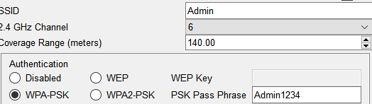Wireless devices connected and functional

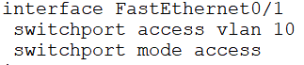

**WAP configuration**

**VLAN configuration**

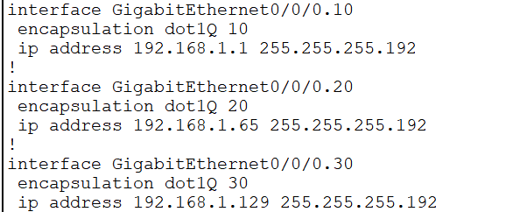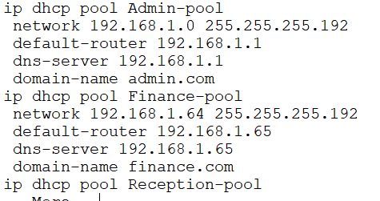

**Inter-vlan configuration**

**Dhcp Configuration**

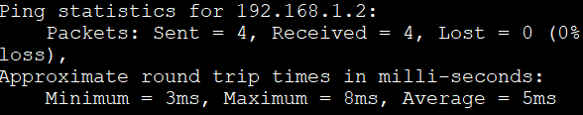

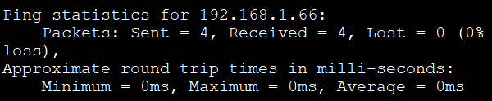

**Pinging Admin**

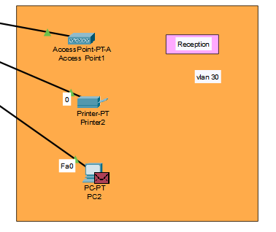

**Pinging Finance**

**Email sent**



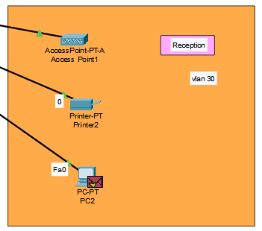

**Communication successful**

**I.6. Conclusion**

* The network design for XYZ Bamenda Branch achieves all key objectives: logical segmentation using VLANs, dynamic IP assignment via DHCP, secure and isolated access, and full inter-departmental communication using router-on-a-stick. The system is scalable—new departments or users can be added with ease—and secure, as VLANs isolate traffic. Wireless access improves user mobility. The use of Cisco Packet Tracer ensured thorough planning and testing before physical implementation.
* With these configurations, XYZ Company can confidently begin operations at their new branch, assured of a reliable, flexible, and professional network infrastructure.